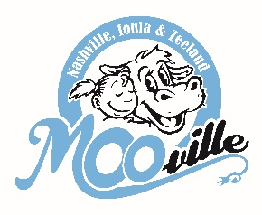
**MINIMUM OF 20 PEOPLE IN ORDER TO BOOK A TOUR**
Farm and Creamery Tour or Tike Time Tour
Form filled out by:________
Tour Confirmed:_______
Date:________

Scheduled tour months are: April-October
(PRICE BREAK: September & October is $5pp for 20+ people for either tour)
Parents, kids, and siblings ALL pay.
NOTE: Petting farm will NOT open until April 15th.
NEW: Your tour will not start until everybody is paid & wearing their sticker. If someone does not have their sticker on, we will ask them to go pay and join the tour after.
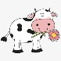
SPRING TOURS – April & May.
Farm & Creamery Tour ($7 per person, all ages.)
Recommended for 1st graders & up. $7pp or $6pp with 50 or more people.
Add $.50 per person to feed the animals in the petting farm.
This takes approximately 1.5-2 hours, depending on the size of the group. Minimum of 20 ppl.
In this tour, you will hear about how we originated, see/pet the baby calves, learn about cow feeds, learn about the momma milk cows & their babies, see where the mo mma cows have their babies, see our farm robots, see the cows be milked by robots, learn about recycling, watch a DVD on our creamery of where we make ice cream, bottle our milk, make butter & cheese curds. Of course, enjoy a free soft serve cone or hand-dipped ice cream ($2.50 extra pp. 1 scoop) Comes with a free goodie bag (school groups only.) Use our pavilion for lunch or a snack. Enjoy our free petting farm with playground & sandbox.
Tike Time Tour: 1 to 5 years old ($6 per person, all ages.)
Recommended for pre-school & kindergarteners.
This takes approximately an hour. Minimum of 20 ppl.
In this tour, you will be able to pet the baby calves, see the big momma cows and watch them be milked. You get a feed cone (one cone per child) to feed all our different animals at the petting farm. As well as enjoy a free ice cream cone. Comes with a free goodie bag. Use our pavilion for lunch or a snack. Enjoy our free petting farm with playground & sandbox.
SUMMER TOURS – June through August. $5 per person.
This tour takes approximately an hour. Minimum of 20 ppl.
In this tour, you will be able to pet the baby calves, see the big momma cows and watch them be milked. You get a feed cone (one cone per child) to feed all our different animals at the petting farm. As well as enjoy a free ice cream cone. Use our pavilion for lunch or a snack. Enjoy our free petting farm with playground & sandbox.
NOTE: If you do not have 20 people to book a tour. Public tours take place every Saturday at 11am. $7 per person. A full Farm & Creamery tour. Or go on a Self-guided tour. $3 per person. Available ANYTIME we are open.
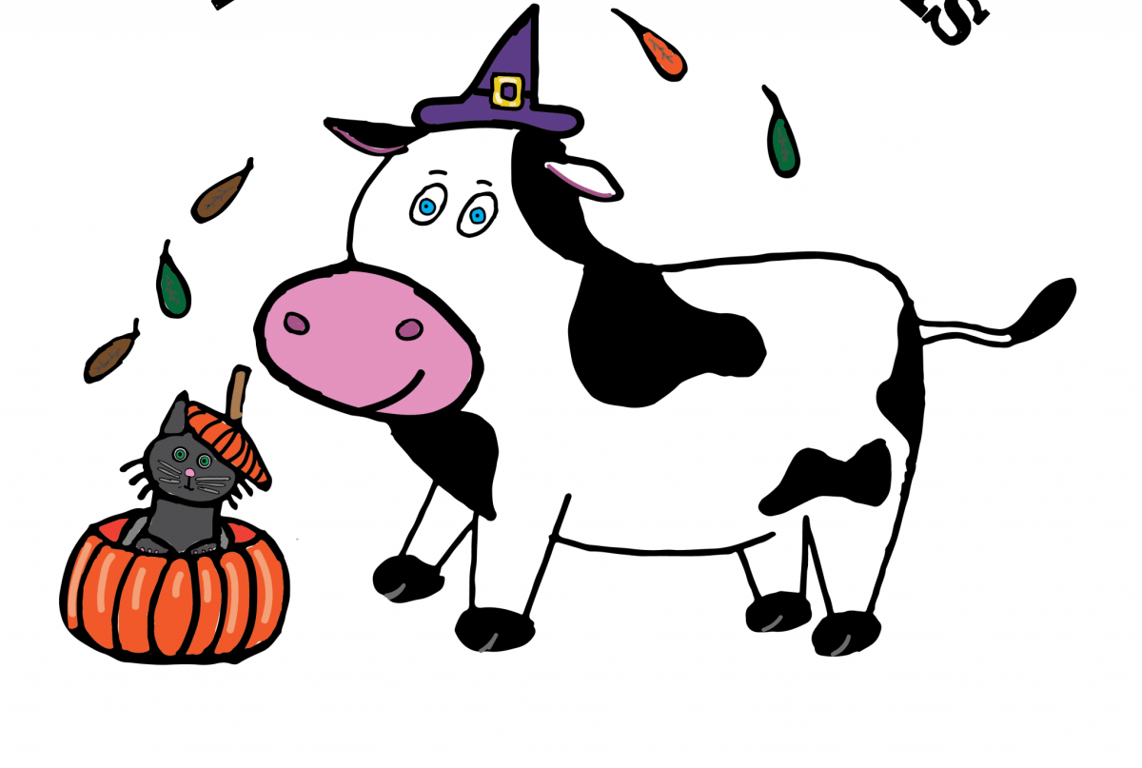
FALL TOURS – September-October. $5 per person.
Farm & Creamery tour or Tike Time Tour
Farm & Creamery tour is for 1st graders & up. Info about tour is listed in the Spring tour section.
Tike Time tour is for Pre-school-Kindergarten. Info about tour is listed in the Spring tour section.

Contact Person:_______________________________________________Phone:________________________________
Group Name & town:________________________________________________________________________________
Grade/Age:_____________# of Adults:_____________ # of Children:_____________ Total #:_____________________
Please note this is your
start time, NOT your arrival time. Your tour will start at your start time.
Tour date requested: ___________________ _____________ _________ _________
Day of week Date Start Time Leave Time

THINGS TO ASK:
1. F&C Tour: Would you like each child to get a .50 animal cone Yes:_______ No:_______
2. Will you be bringing sack lunches? Yes:_______ No:________
-Milk is available by the gallon for sack lunches $3.25/white and $4.25/Chocolate. We ask that you do NOT bring other milk onto our facility.
3. How will you be arriving? Bus Yes:_______ No:_______
-Parents/Chaperones Car Yes:_______ No:_______
If yes, please park on the west side of the parking lot to ensure room for our customers. Please do NOT park directly in front of MOO-ville, you will be asked to move before we start if you are.

4. Ice Cream upgrade for tours (Hand-dipped instead of soft-serve) $2.50 x ________# amount in your group.
Lunch Specials for Groups of 10 or more people.
1. ALL-beef Hot Dogs, chips and Milk $4.50 x__________# of lunches
2. Ham or Turkey cheese wraps, chips and Milk $5.50 x__________# of lunches
3. Walking Tacos & milk (summertime ONLY) $4.50 x__________# of lunches

THINGS TO KNOW:
  - We will not be doing tours after noon during June, July & August (too hot). April, May, September & October we can do an am tour OR an afternoon tour!
  - Your arrival time is your start time, please be sure to come 15 minutes early to use the bathroom.
  - Our max # of people is 150. When inviting parents, we usually get a fair # to attend. Be sure to be aware of that when you are stating your # of adults as we do not have room for over 150 people in total. We still want you to be able to come to MOO-ville if your group is over 150, just break your group up into multiple days.
  - Parents/Siblings are NOT free BUT encouraged to enjoy the tour with their kiddos & make some memories on our farm
  - Groups of 50 and over will not be able to be accommodated with rain, please call to reschedule. We will call you the day before to decide together. Overall, if it is raining to hard at our facility to accommodate, then we will have the final decision.
  - Bus drivers get a free tour; as well as one teacher per classroom (must have 20-25 kids per classroom)
  - Homeschool groups must pay as one group & each parent per family is not free; the 1 contact person is free
  - Lunches will take place under the pavilion outside. (APRIL & OCTOBER: only groups of 40 can eat inside @ at time)
  - 3.75% fee for using a credit/debit card
    - Please bring cash or a check to avoid fees
    - Must pay day of
  - Can email/fax an invoice if needed for prior authorization
  - $20 fee if not paid the day of or prior

