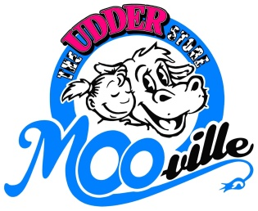
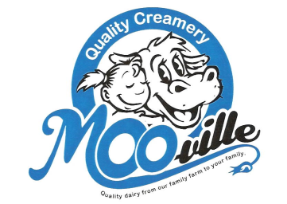
Sponsor-A-Day
Need Fundraising ideas for your school, business
or organization? MOO-ville has a few for you!!
Sponsor a Day is where your organization receives 10% of the sales for that day. But your organization has to do the advertising for MOO-ville. You have to come up with 5 different ways you are going to advertise your fundraising day at MOO-ville. Some ideas that have been used in the past have been newspaper ad, flysheets, Facebook, phone recordings, letters, personal invites, posters, etc. It really is quite simple if you get your whole team/organization involved instead of just one person. Feel free to come and set up a table showing of who you are and what you are about to show off your cause and help your sales!
So just a recap, here are the 3 simple steps
- Pick a day! Monday, Tuesday, Wednesday, or Thursday are your options.
- Your next job? Advertise that date. It’s that simple!!
- Last job? Tell us 5 ways that you used to advertise your “sponsor a Day at MOO-ville.” (Social media is 1 form of bracket)

10% of the sales for the day you have selected is given to your group or organization.
Minimum is $100 that you will receive.
Guidelines & Rules:
-Monday-Thursday are the only days you can pick
-Only allowed twice in a year (if you don’t reach our criteria on sales the first time, you are not allowed to do it again, determined by management)
-NOT allowed May-August
-list 5 ways you advertised (1 month in advance)
-Check needs to be made out to an organization, not an individual person
-holidays are not allowed to be selected as a date
-no double dipping, one store. You can’t choose the Nashville store & Ionia store for 4 times in a year. You can choose 1 & 1 or both at either store.
-when posting about your event on Facebook, tag which MOO-ville location you are doing in the post
-Passing out flysheets that look like what is attached has been the most beneficial way other than making an event on Facebook and inviting all of your friends.
-We do NOT send checks in the mail, have to pick up at point of business.
-We have the right to host you at our business or decline you if we do not see a return on investment.

Pints of Milk Fundraiser is also an idea!
Got Milk? We Do!!!
Order pints of Chocolate, white or strawberry milk (strawberry milk only available through the school year) You pay $1.00 each
Suggested sale price $1.50
Call MOO-ville 517-852-9003 or Tina Westendorp 269-838-8354 to set up your fundraising
event.
-------------------------------------------------------------------------------------------------------------------------------

Who Check needs to be made out to:_______________________________________________

Head person:________________________________ Phone Number:______________________

List 5 advertising methods: __________________________ _________________________

__________________________ _________________________

_________________________

MOO-ville management has the authority to not allow a group/organization to sign up/sign up again. If we feel you are using the system, we can cancel the sponsor a day at anytime or that you did not meet your 5 ways of advertising.

Head contact signature:__________________________________________________________

